Experiment-4
Student Name:Raj Kumar Singh UID: 23BCS11393
Branch: CSE Section/Group: KRG-3B
Semester: 6th Date of Performance: 04/02/26
Subject Name: System Design Subject Code: 23CSH-314

- AIM : To design an scalable OTT platform (Similar to Netflix or Amazon Prime)

- Objective:
• To design and specify an OTT platform that supports user onboarding, subscriptions, content discovery, and video streaming.
• To define functional and non-functional requirements ensuring scalability, availability, and low latency.
• To identify core system entities and design RESTful APIs for seamless client interaction.
• To ensure high availability for video streaming while maintaining consistency in payments and subscriptions.

- Tools Required:
• Frontend: HTML, CSS, JavaScript, React.js
• Backend: Node.js, Express.js
• Database: MongoDB
• API Testing: Postman
• Authentication: JWT
• Media Storage: Cloudinary / AWS S3
• Version Control: Git, GitHub
• Deployment: AWS / Render / Vercel

- SYSTEM DESIGN / SYSTEM SPECIFICATION:
  - Functional Requirements:
- Client should be able to create account on the OTT platform.
- After the successfull login, client should be able to opt for the subscription plans.
- Client should be able to search for the shows/movies based on the video title or names.
- Client should be able to watch the videos / tv shows in multiple different resolutions (480p,720p,1080p, 4k etc.)
- Recommendation for TV shows and movies.

  - Non-functional Requirements:
- Scalability: 200-300M, for which let's say total videos we are having are 20K videos (~1 hour each)
- CAP Theorem: Availability >>>>> Consistency
Availability on watching TV shows and movie
Consistency in making payments and in subscription plans
- Latency: 50 - 80 ms
Client should be able to see the video with zero or neglibile buffering.
  - Core-Entites of the System:

  - Client
  - Clients Metadata
  - Video / TV shows
  - Video metadata: (images(Thumbnails + description)

  - API Endpoints Creation:
A. Client-Onboarding
    - POST Call: https://www.netlfix.com/user/register
    - POST Call: https://www.netlfix.com/user/login
    - PUT Call: https://www.netlfix.com/user/update
    - User Data Update: PUT API CALL: PUT / api / users / {user_id} / profile

B. Subscription

- GET Call: https://www.netlfix.com/Get-subscription-plans
- POST Call: https://www.netlfix.com/subscription
{
userMetadata,
subscriptionID
}

C. Searching & Video Playing
- GET Call: https://www.netlfix.com/search?q={movie_name}
Response: List<Video_ID> + some meta data of video
- GET Call: https://www.netlfix.com/{video_ID}
Response: Metadata of the video (JSON)
- GET Call: https://www.netlfix.com/play/{video_ID}

- HLD(High Level Design):

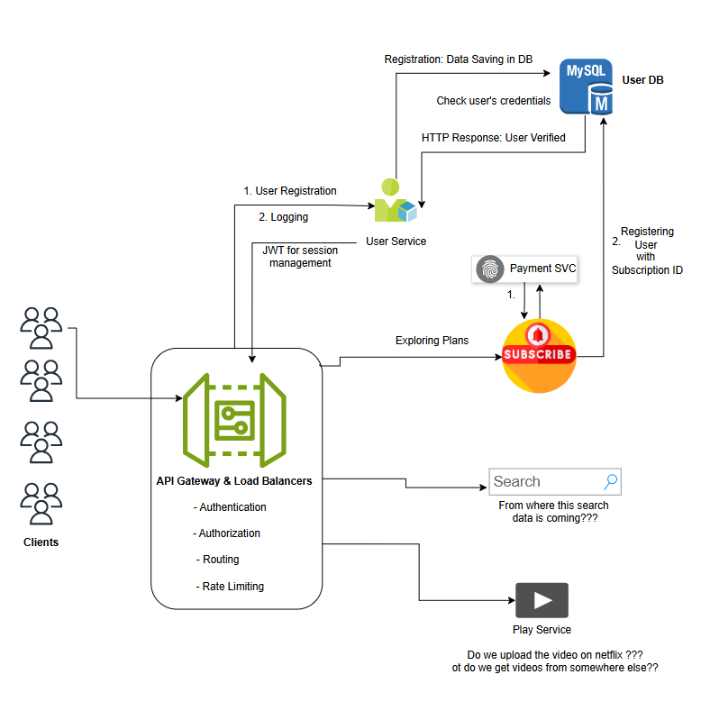


DEPARTMENT OF
COMPUTER SCIENCE & ENGINEERING

- LLD(Low Level Design

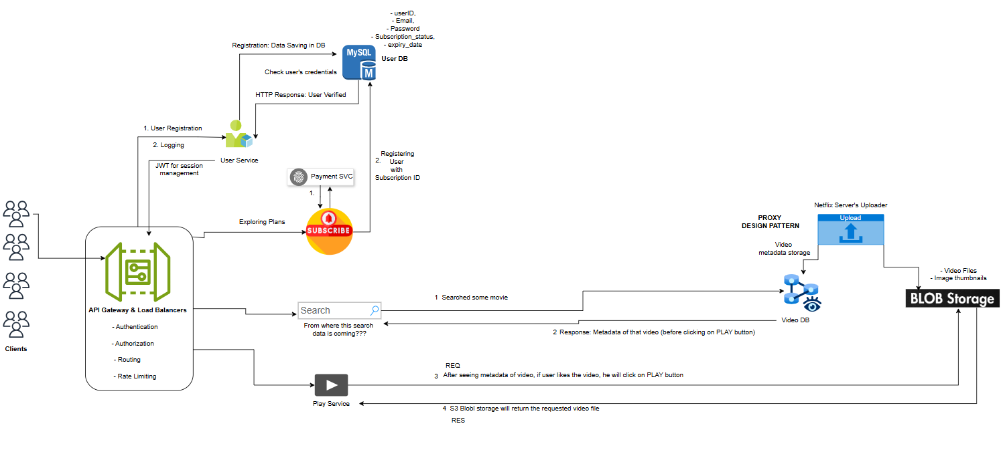

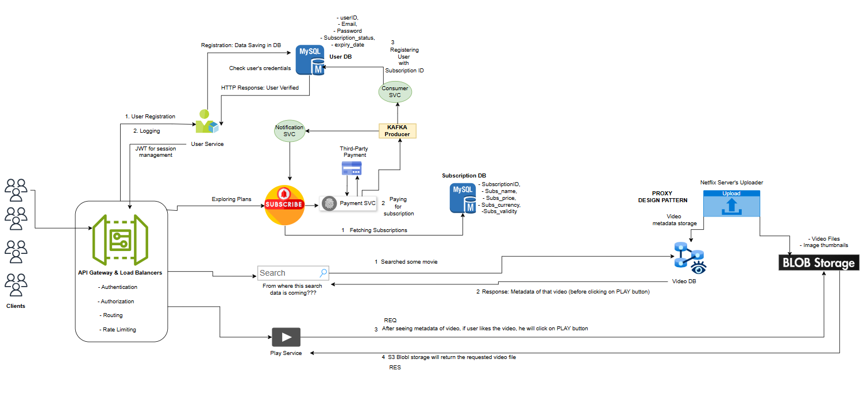

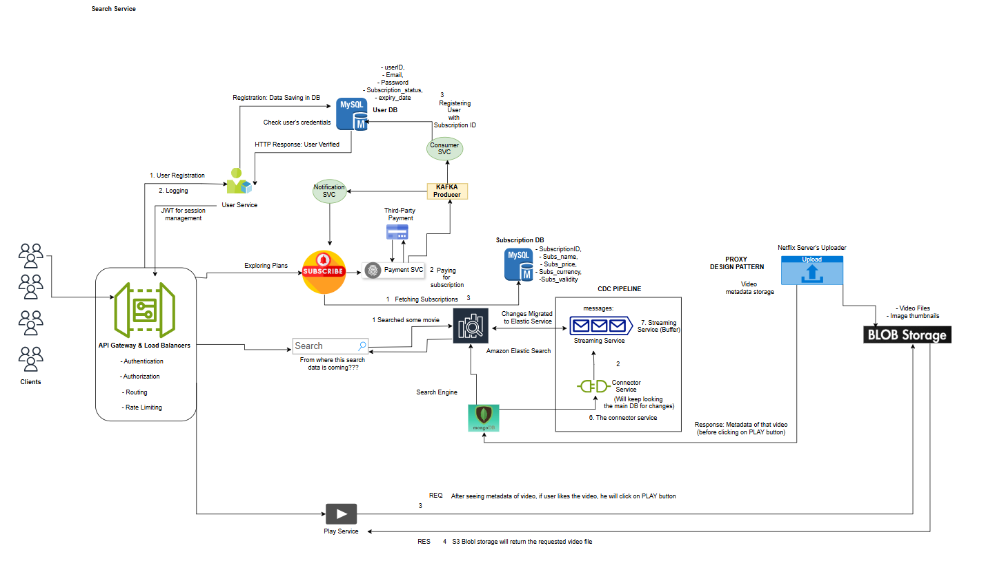
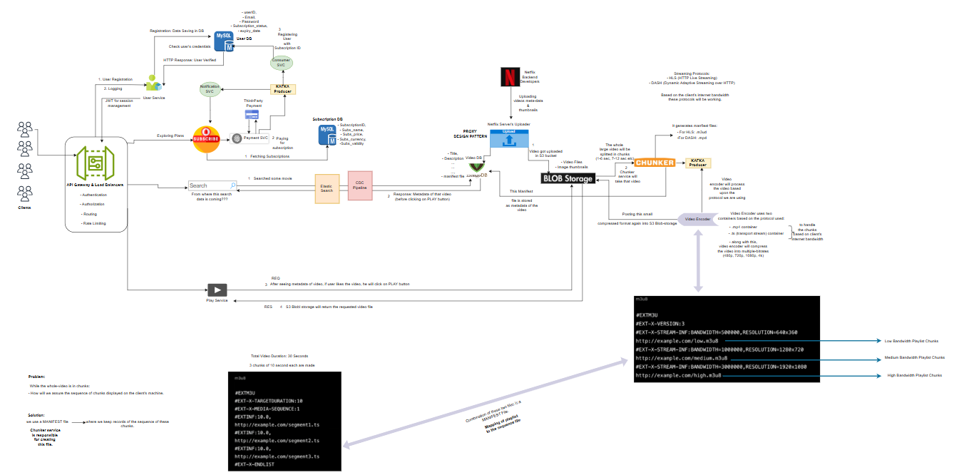

- Learning Outcomes

• Understand and document functional and non-functional requirements of a large-scale OTT system.
• Apply CAP theorem concepts in real-world system design scenarios.
• Identify core entities and their roles in system architecture.
• Design RESTful API endpoints for user management, subscriptions, search, and video playback.
• Analyze scalability, availability, and latency requirements for high-traffic applications.

